Our World

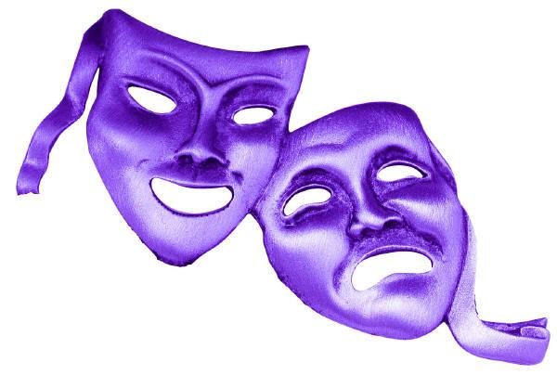

Aims:

- For students to use physical theatre techniques to develop their confidence and communication skills.

- For students to learn about various cultures from around the world using physical theatre.

- For students to understand how humans are destroying the earth and wildlife whilst exploring the techniques they have learnt.

Week 1 (2 hour workshop)
Aims:
- Students will develop their understanding of the role of physical theatre in drama
- Students will explore spontaneity and creativity within their work
Physical Theatre – definition and purposes  Approx 5 mins | Whole group discussion  - What is physical theatre?  - Physical theatre is a style of drama whereby you can tell a story using little to no dialogue – we will focus on predominantly rehearsed PT/ developing creative skills through PT  - Physical theatre can be useful to explore complex social and cultural issues.  - What skills are needed for successful Physical Theatre?  - movement/mime/gesture/dance/facial expressions.......
Group/pair work  Approx 10 mins | Freeze Frames  - Introduce to students what a freeze frame is. Discuss: What is a freeze frames purpose?  - Students should take an experience they have had to create a still image. For example: playing football, going to school etc.
Whole group activity  Approx 10 mins | Animal workshop:  - Students must create an image of the animal they are given as a group.  - Students can develop their image to create movement.  Consider purpose of game with class – which of the key skills discussed would this develop? | Possible topics!  Lion  Elephant  Rhino  Hippo  Snake  Tiger
Group work  Approx 10 mins | Soundscape workshop:  - Students will create a soundscape of different locations using their voices and body.  - Students can develop their soundscapes by adding in movement. | Possible locations!  Rainforest  Busy City  School  Ocean
Group work  Approx 10 mins | Stimulus:  - Students will learn what a stimulus is and how it can be valuable in creating a piece of drama.  - Students will discuss their feelings towards the stimulus. | Stimulus:  Students will be given different images to respond to.
Group work  Approx 30 mins  Approx 30 mins | Devising:  - In their groups, students will create a performance based on their stimulus, using the techniques we have explored.  - Students will perform and give each other feedback.

Week 2 (2 hour workshop)
Aims:
- Students will explore different cultures through the use of physical theatre.
- Students will consider how different techniques can highlight aspects of their performance.
Whole group discussion  Approx 5 mins | Cultures around the world:  - Students will have a group discussion of cultures they are aware of.
Whole class warmup!  Approx 10 mins | Status:  - Students will discuss what status is. Who is of a high and low status in their lives? How is this reflected in different cultures?  - Students will walk around the room. I will say numbers between 1-5(1 of being low status and 5 of being high). The students must change their posture and body language to represent the different status.
Group work  Approx 15 mins | Day of the Dead:  - As a class we will discuss the history behind ‘Day of the Dead’.  - Students will explore the use of repetition to portray ‘Day of the Dead’ and see how beneficial it is for a piece of drama.
Group work  Approx 15 mins | Huli – Papua New Guinea:  - As a class we will discuss the history behind ‘Huli – Papua New Guinea’.  - Students will use soundscapes and repetition to convey the tribe they have looked at.
Group work  Approx 15 mins | Syria:  - As class we will discuss the war his Syria.  - Students will look at refugees and the travel they have to do to safety. They will focus of the boat journey. They can use cello tape to create various sizes of the boat around them. The different space can allow students to explore different ways of using their bodies. Students should consider the people around them, travel across water and the conditions that these people would be in.
Group work  Approx 30 mins | Devising:  - Students should pick one of the cultures and devise a performance using the techniques we have used.
Class work  Approx 30 mins | Performing:  - Students will perform to each other.  - The audience should identify the culture they are representing and be able to give constructive feedback.

Week 3 (2 hour workshop)
Aims:
- Students understand how humans are destroying the planet and explore how they can be the change.
- Students create an imaginative scene portraying our environment through the use of the techniques we have looked at the past three weeks.
Whole class discussion  Approx 5 mins | Environment:  - Students will discuss the damage they are aware that is being done to the environment by pollution, acid rain, deforestation etc.  - Students will then primarily focus of the melting of the Ice Caps.
Whole class warmup  Approx 10 mins | Animals:  - Students will walk around the room and will be asked to become an animal.  - They will then slowly develop into the animal after suffering from their home being destroyed. Students should think about how their bodies changed when they changed their space with the Syria project. | Animal topics:  Polar Bears  Penguins  Seals  Walrus
Group work  Approx 15 mins | Rainforest:  - Students will discuss how acid rain is killing fish and how plastic waste affects the ocean.  - Students will use freeze frames to show the ocean without plastic waste and one with plastic waste. Students will discuss the differences we see. They will then develop into movement to represent fish. Students can add thought tracks of how the animals may feel.
Whole class discussion  Approx 10 mins | What can we do?  - Students will discuss what difference we can make to save the planet.
Group work  Approx 15 mins | Freeze frames:  - Create a performance on how the earth is impacted by pollution etc. How can one person make that difference?  - Begin by creating 3 freeze frames (beginning, middle, end).
Group work  Approx 30 mins  Approx 30 mins | Perform:  - Develop the freeze frames into a performance using all the techniques we have explored the past 3 weeks.  - Evaluate the performances.

